**Realistic Modeling of the Complex Morphology of CNT-Reinforced Nanocomposite using Immersed Finite Element Simulations**

X Chen, AR. Alian and SA. Meguid*

Where is the address?

Abstract In this article, we overcome the major difficulties associated with the FE modeling of complex CNT morphologies in polymeric nanocomposites. These difficulties are typically overcome by the introduction of many unnecessary simplifying assumptions and a much-reduced cell size to reduce the degree of freedom of the problem to enable its treatment. To overcome these unnecessary simplifying assumptions, we adopt an Immersed FE method that allows the CNT and the polymer to be created independently but simulated as a coupled system. In this case, it is assumed that the CNT and the polymeric nanocomposite are fully bonded, and that the equilibrium equations of the system are strictly obeyed. The most important advantage of the newly developed Immersed FE method is that the polymer can always be discretized as a regular grid, irrespective of the complex nature of the CNT network. Our new method made it possible for us to simulate realistic composites containing complex CNT configurations. This is almost impossible by using the traditional FE method due to the dramatic difficulties in meshing process and the huge element numbers. Although the polymer and CNT grids are independent, numerical examples demonstrate that the results of the Immersed FE method are very close to the results of the traditional FE method. Finally, the newly developed method is used to study the influence of CNT waviness on the material properties of polymeric nano-composites.

1. **Introduction**

In the area of nanocomposite science, the carbon nanotubes (CNTs) have attracted considerable interest due to their remarkable mechanical and physical properties, such as such as low density [11], high Young’s modulus, strength and fracture strain [1,7,9,19] and high thermal and electrical conductivity [14,26,33]. These superior properties make it an excellent choice to reinforce pure polymer as the multi-functional composite. In the past few decades, intensive attentions are paid to understand the mechanical behavior of the nanocomposite through experimental [20,23,24], analytical [15,17,31] and numerical studies [5,18,24,28].

Numerical simulation is widely used in studying the mechanical properties of nanocomposites and a variety of modeling methods are developed for different scale of interest. The Molecular Dynamics (MD) method is designed for the nano-scale simulation. The constitutive relations of the MD method are derived from the inter-atomic potentials, and the motion of each atom in the system is based on the forces applying on it. MD method is able to see the details of every atom, so it can be used to study the complex phenomena in nano-scale, such as the interfacial properties between CNT and polymer [4,12,30], the effect of the chemical functionalization on carbon atoms [27,35] and the influence of the defect in the CNT [8,25]. However, even with the usage of the most advanced supercomputers, only about atoms, namely about 1000 atoms in each direction, can be simulated [10]. So it is unrealistic to use MD method in a larger scale.

To enlarge the simulation scale, the traditional continuum model is introduced which assumes the material to be homogeneous and neglects the details of atomic structures. Although the traditional continuum models cannot accurately describe the phenomena in nano-scale, it is able to provide valuable information to study the influences of the micro-scale parameters, such as the CNT curvature [2,3,22], aspect ratio and volume fraction [13], on the effective material properties of CNT-reinforced composites.

Finite Element (FE) method is the most commonly used technique to simulate nanocomposites in micro-scale. However due to the extreme complexity of the CNT net morphology, such as waviness, agglomeration and aggreation, it is almost impossible to create a FE model for a realistic composite. The major challenge comes from the meshing process because traditional FE method requires the CNT and polymer grids to be matched to each other. The difficulty increases significantly with the increment of CNT number and morphological complexity. Lusti and Gusev created the traditional FE model of composites with straight CNTs [13] and Fig.1 shows the grid. It is obvious that the grid should be very difficult to be created and a lot of highly distorted meshes appear in Fig.1 (b) which may decrease the accuracy of the results. The volume fraction of CNT is only 0.5% but the composite is meshed into elements. Alian and Meguid also used the traditional FE model to study the mechanical-electrical behavior of composites reinforced by straight CNTs [6], but due to the difficulties in meshing, the CNT volume fraction is only 0.3% in their research. The problem can be even more severe when consider the waviness and agglomeration in the realistic composites.

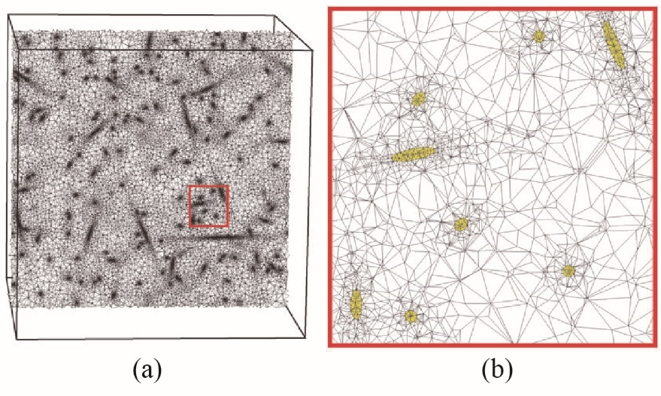

Figure.1: The traditional FE model of a composite with straight CNT. (b) is the magnification of the red framed section shown in (a).

To avoid the complicated meshing process, many assumptions are made in the past. The simplest way is to reduce the number of CNT and the morphological complexity. For instance, Fisher studied the influence of the waviness by FE models which contain only a single nanotube [22] and Chen did research about the mechanical response of composites with regular CNT distribution [36]. The other way is to use the effective composite material properties which are calculated from the Mori–Tanaka model [29]. The CNT net does not need to be meshed explicitly in this method, but the details of the CNT deformation are also ignored [21]. The “embedded element technique” [22] is also an approach to simplify the meshing process. The CNTs are meshed as beam elements and their freedom degrees are embedded into the polymer by modifying the stiffness matrix of each polymer element. Only kinematic relation between CNT and polymer is considered in this method while the more important issue, the interacting forces in between, is not accounted for. Moreover, the usage of beam element also fails to consider the effect of different Poisson's ratio between CNT and polymer. In summary, the simplification of the meshing process also decreases the accuracy of the results, so these methods can only reveal part of the realistic phenomena.

In this study, an Immersed Finite Element method is proposed which not only simplifies the meshing process but also provides results in high accuracy. In this method, the CNT and polymer grids are both meshed into solid elements and they can be created independently. It means that the polymer can always be meshed as a regular grid no matter how complex the CNT nets are. The CNT net and polymer are simulated coupled according to a basic “fully bonded” assumption. Rather than the “embedded element technique” which just embed the CNT freedom degree, the equilibrium equation of each CNT is embedded into the equilibrium equation of the polymer according to the Newton's third law. Therefore, both kinematic and mechanic relations between CNT and polymer are considered in the Immersed FE method. The accuracy of the Immersed FE method are validated by comparing the results with the traditional FE method, and numerical examples demonstrate that they are very close to the results of the traditional FE method.

It should be mentioned that the Immersed FE method is not only suitable to simulate the nanotube-reinforced composites, it can also be used to simulate the mechanical behavior of particle-reinforced composites in the same way.

The remaining of this paper is organized as follow. In Section 2, the basic idea, assumption, governing equation and the solution scheme of the Immersed Finite Element are introduced. Subsequently in Section 3, two numerical examples are presented to validate the results from the proposed method. Subsequently, the Immersed FE method is used to study the influence of CNT waviness on the material properties of nano-composites. Finally, the conclusion is summarized in Section 4.

1. Immersed Finite Element Method

The flowchart of the Immersed Finite Element method is shown in Fig.2. Fig.2 (a) is a uniformly dispersed wavy CNT net with 2.5% volume fraction. It is very difficult to create the corresponding composite grid using traditional FE method. But in the Immersed FE method, the polymer grid could just be meshed as a regular grid shown in Fig.1 (b). The size of the polymer element depends on the accuracy requirement. Finally, just put the CNT net and polymer grid together as shown in Fig.1 (c), the Immersed FE method can output the reliable results.

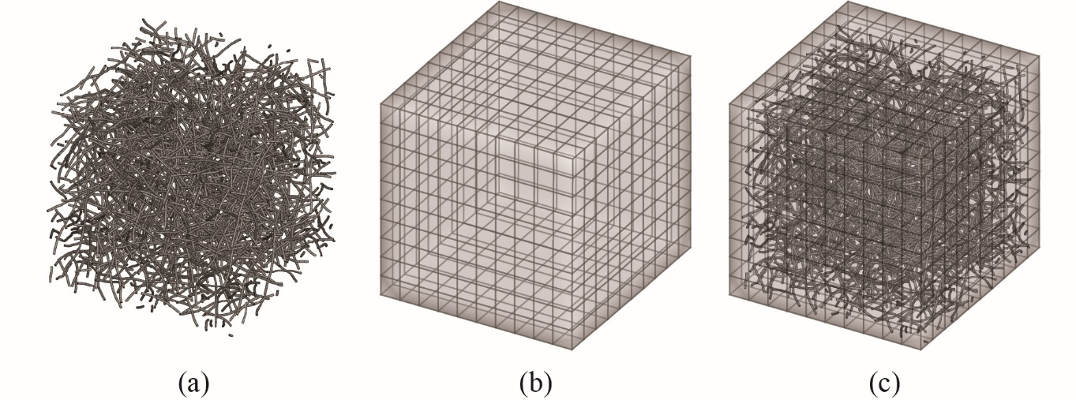

Figure.2: The flowchart of the Immersed FE method.

The most important advantage of the Immersed FE method is that the polymer can always be meshed as a regular grid no matter how complex the CNT nets are. It is possible to simulate realistic composites because the difficulty of creating a realistic CNT net model is much less than creating a realistic composite model.

The following of this section will introduce the basic idea, assumptions, governing equation and the solution scheme of the Immersed Finite Element.

* 1. Basic assumption and the governing equation

The polymer and the CNTs are both meshed with 8 node hexahedral elements in the proposed Immersed FE method, but they are not matched. The basic assumption is the polymer and CNTs are fully bonded, namely the displacement of the CNT surface nodes equals to the local polymer displacement. This assumption is widely used in continuum model [2,6,13,36] although they are not perfectly bonded in reality and may influence to effective material properties [16]. But it is also reasonable for small deformation where the stress in CNT can fully transferred to the polymer [32].

In the Immersed FE method, the CNTs' grid are not matched with the polymer grid, so the displacement of the CNT surface nodes should be gathered from the surrounding polymer nodes. Once the surface displacement of the *i* th CNT, namely is determined, the internal displacement and the reacting force can be obtained by solving the equilibrium equation

⑴

is the force that the polymer applies on , so the force that applies on polymer is according to the Newton's third law. It should be mentioned that this force is not exactly applied on the polymer nodes, so it should be scattered to the surrounding polymer nodes. Since is calculated is from the polymer displacement , the force that applies on the polymer should also be a function of and denote it as .

Then, the equilibrium equation of polymer is

⑵

Eq.⑵ is the governing equation of the Immersed FE method and the whole system can be determined after solving this equation.

* 1. Properties of the governing equation

We will prove that Eq.⑵ leads to a linear equation with positive definite coefficient matrix in the following.

Suppose the number of freedom degree in the polymer grid is and the number of the boundary freedom degree in is . For the *j* th boundary freedom degree in , its displacement is gathered from the surrounding polymer nodes, namely

⑶

where is the contribution of the *k* th polymer freedom degree to the *j* th boundary freedom degree of in the displacement gathering. Eq.⑶ can be rewritten as

⑷

where is the displacement gathering matrix with dimension .

The solution of Eq.⑴ is

⑸

where must be a positive definite matrix due the conservation of energy. Therefore, the force that applies on polymer is

⑹

and it should be scattered to the surrounding polymer nodes, namely

⑺

where is the force scattering matrix with dimension .

Substituting Eq.⑷ into Eq.⑺, we have

⑻

In this paper, the isoparametric interpolation of the 8-node hexahedral element is used to gather displacement and scatter force. So , and Eq.(8) can be rewritten as

⑼

where is a positive semi-definite matrix.

Finally, Substituting Eq.⑼ into Eq.⑵ leads to

**⑽**

is the total stiffness matrix of the nanocomposite which contains the original stiffness from the polymer, namely ***K***, and the reinforced stiffness from CNTs, namely ***S***.

Strictly speaking, ***K*** should not be equal to the stiffness matrix of the pure polymer . This is because the CNTs in the composite occupy some space of the polymer and thus, decrease the stiffness of the polymer. Nevertheless, since the volume fraction of the nanocomposite is very low (generally less than 5%), and the stiffness of CNT is much higher than that of the polymer (about 300 times), the magnitude of should be much less than the magnitude of ***S***. So in this paper, is used in Eq.**⑽** for the sake of simplicity.

Dividing into the active freedom degrees and the constraint freedom degrees, Eq.**⑽** changes to

⑾

and the Finally equation is

⑿

It should be mentioned that is a positive definite matrix and is a positive semi-definite matrix, so the coefficient matrix of Eq.⑿ is positive definite.

* 1. Solution scheme

Although Eq.⑿ is a linear equation, it is almost impossible to calculate the coefficient matrix directly because the expression of and can be very complicated. However, can be easily obtained by solving Eq.⑴ for each CNT and summing over all . Therefore, the CG (Conjugate Gradient) iteration can be used to solve Eq.⑿.

The flowchart of the CG iteration is shown in Algorithm.1 where and are known while and are unknown variables. Note that

⒀

so equals to the components of related to the active freedom degree. Similarly,

⒁

so equals to the components of related to the active freedom degree subtracting .

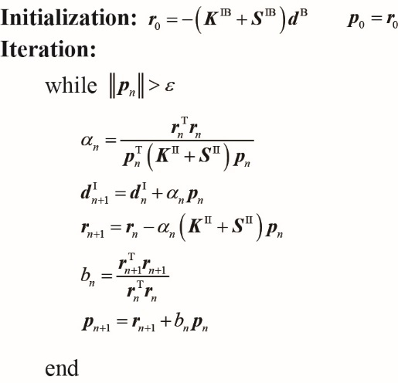

Algorithm 1: The flowchart of the CG iteration.

1. Validation and numerical results

In this section, two numerical tests are presented at first for the validation of the method proposed in this paper, namely to demonstrate that the results from the Immersed FE method are close to the results from the traditional FE method. the Immersed FE method is used to study the influence of CNT waviness on the material properties of nano-composites.

* 1. One CNT validation

In this example, one SWCNT selected to be (5,5) armchair of radius and length is put into a polymer. The size of polymer is and the CNT is displaced in the center of the polymer as shown in Fig.3. The material properties of the CNT and polymer come from MD simulation, namely , and , . The boundary condition is at face , at face , at face z, and at face .

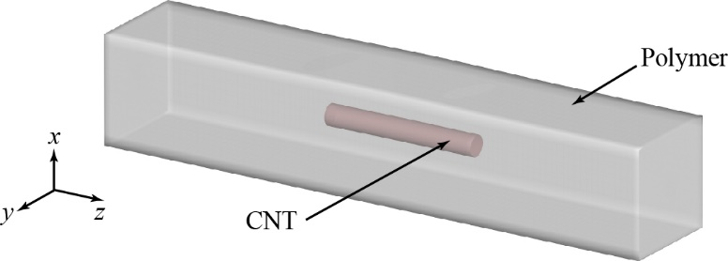

Figure.3: The model of the one CNT validation.

This problem is simulated by both the traditional FE method and the Immersed FE method proposed in this paper. The local view of the traditional FE model near the CNT is shown in Fig.4 and the CNT and polymer meshes are matched. The number of cells in the traditional FEM model is 168300. In the Immersed FE model, the CNT grid is the same with that in the traditional FEM while the polymer is meshed as a regular grid with cells. The number of cells in these two models is close, so they have a similar grid resolution.

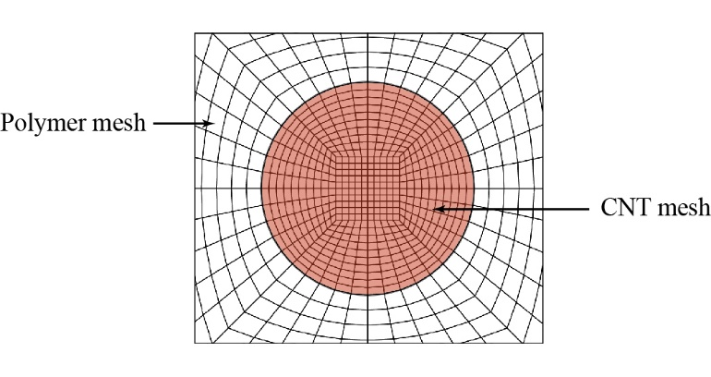

Figure.4: Mesh-matched FEM model

The contour of the CNT are compared in Fig.5. The distribution in Fig.5(a) and (b) are very similar in most place while the stress at the endpoints of the CNT are overestimated. The overestimation may occur if one or more CNT cells at the endpoint are fully inside a polymer cell, and it can be eliminated by using a refined polymer grid or a coarser CNT grid. Fig.5(c) shows the contour if the polymer is meshed in , and the stress overestimation is almost disappeared.

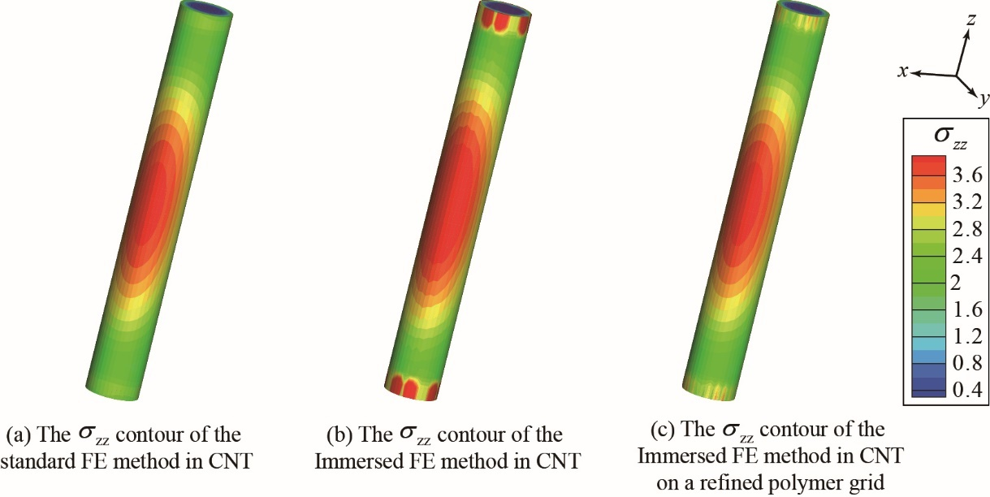

Figure.5: The comparison of the in CNT.

Fig.6 presents the polymer comparison near the CNT, and the stress distribution are also very similar in most place. The degree of the stress concentration phenomenon near the CNT's endpoints is underestimated due to the non-matched polymer and CNT grid, and it can also be eliminated by using a refined polymer grid as shown in Fig.6(c). It should be mentioned that the underestimation is localized because the equilibrium equation is an elliptic equation. Therefore, it would not produce obvious error when evaluating the effective material properties of the nanocomposite. Fig.7 shows the contour at the polymer boundary, and the results from the traditional and Immersed FE method are almost the same.

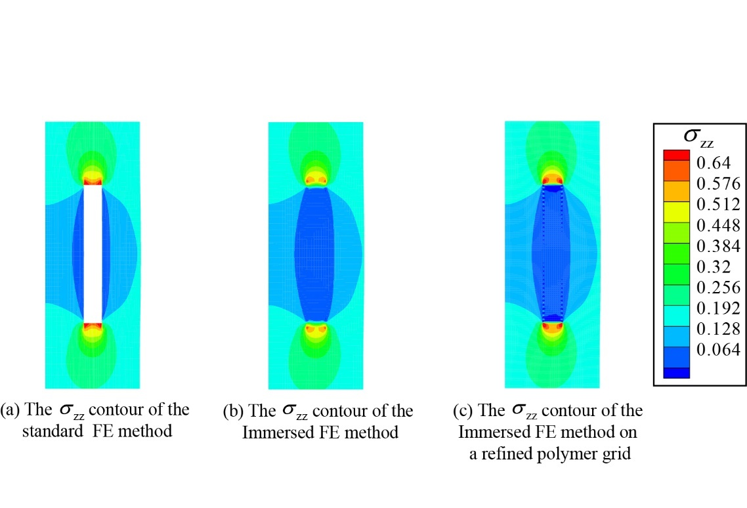

Figure.6: The comparison of in polymer near the CNT.

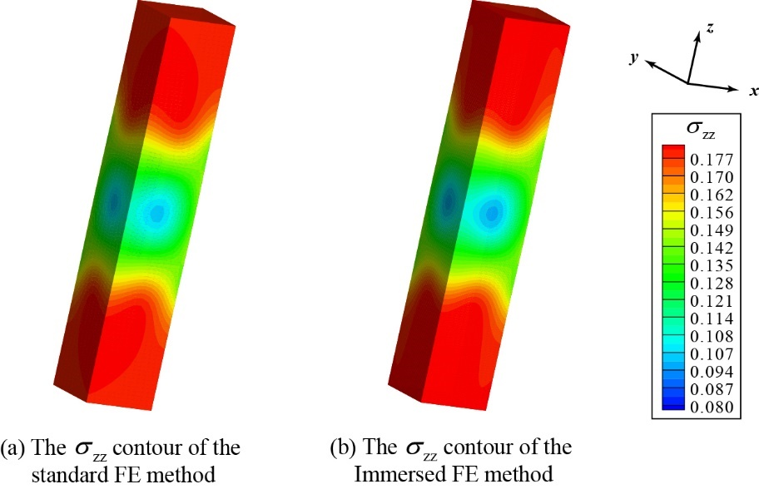

Figure.7: The comparison of in polymer near the boundary.

* 1. CNT nanocomposite validation

In this example, 11 SWCNTs with *r* = 0.67 nm and *l* = 67 nm are randomly put into the polymer as shown in Fig.8. The traditional and Immersed FE method are used to calculate the effective material properties. The size of the RVE (Representative Volume Element) is *L* = 67 nm and the material properties of CNT and polymer are , and , , respectively. The CNT net and polymer grids are matched in traditional FE method, while in the Immersed FE method, the polymer is meshed as regular grid. The boundary condition is at face , at face , at face z, and at face .

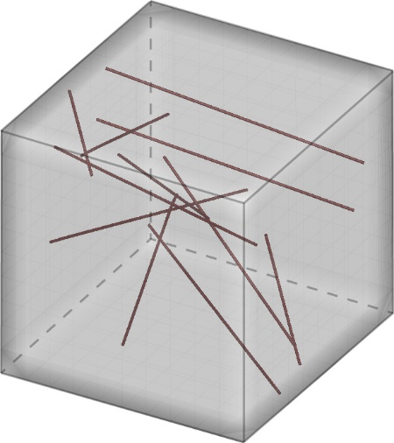

Figure.8: The CNT distribution in the nanocomposite.

The results of effective stress are compared to validate the results of the Immersed FE method, where is the *x*-component of the reacting force at face *x* = 0 and *S* is the face area. Different polymer grids are used in Immersed FE method and define the grid resolution as

⒂

where is the diameter of the CNT and is the length of the polymer cell.

Fig.9 shows the results of the relative error on different polymer grid resolution. It indicates that the effective stress from Immersed FE method is very close to the result from traditional FE method. Moreover, the error between Immersed and traditional FE method decreases when using higher polymer grid resolution and the error is almost vanished at .

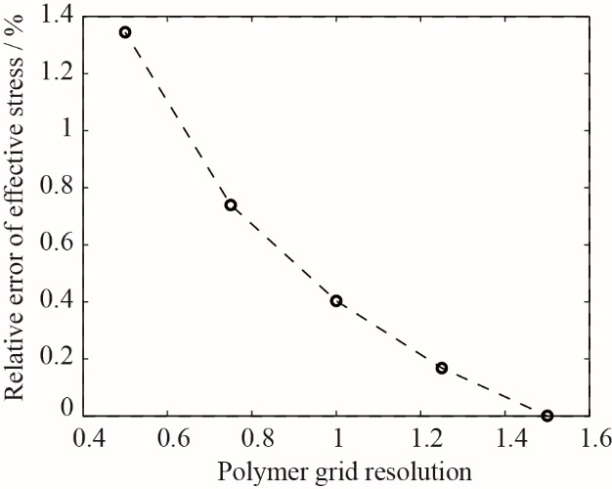

Figure.9: The variation in effective stress error versus polymer grid resolution.

The displacements of CNT endpoints are also compared. An auxiliary variable is defined to measure the average displacement difference as

⒃

where and are the displacement of *i* th CNT endpoint from traditional FE method and Immersed FE method, respectively. The results on different polymer grid resolution are shown in Fig.10 and the error in CNT displacement is around 5.5%. The CNT displacement from Immersed FE method is also close to the result from traditional FE method, but the convergence rate of displacement is much lower than the effective stress. It may be caused by the intrinsic displacement error from the non-matched meshing. Nevertheless, the Immersed FE method is able to produce reliable results to describe the nanotube displacement and deformation. So it can be integrated with electrical or thermal models to study the multi-functional properties of nano-composites.

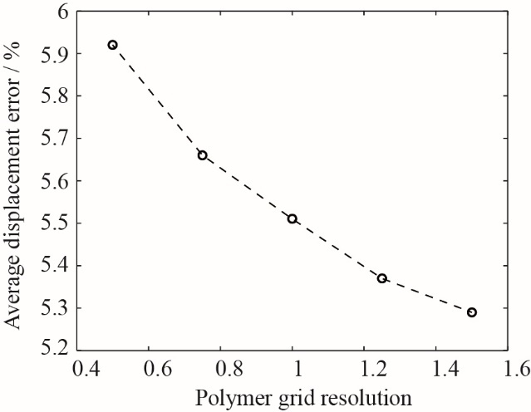

Figure.10 The variation in average displacement difference versus polymer grid resolution.

* 1. Influence of CNT waviness on material properties of nano-composites

To validate the capability of the proposed method in solving complex problems, the Immersed FE method is used to study the effect of CNT volume fraction and waviness on the Young’s modulus of nano-composites. The CNT is selected to be Single-Walled (5,5) armchair with *r* = 0.67 nm and *l* = 67nm. These CNTs are uniformly and fully dispersed in a brick RVE with size *L* = 67nm. “Fully dispersed” means that the minimal distance of any two CNTs in the net must larger than where is the distance of Van Der Waals force [6]. The combination of 3 volume fractions and 4 curvatures are studied. At each combination , 3 sets of random CNT net are created by Monte Carlo method. Periodic condition is applied at the RVE boundary. Fig.11 shows 3 CNT net samples with and different curvatures. The CNT morphologies are very close to the realistic SEM image [3] in Fig.11(d) and it is very difficult or even impossible to create the traditional FE methods for these nano-composites. The polymer grid resolution is for all cases.

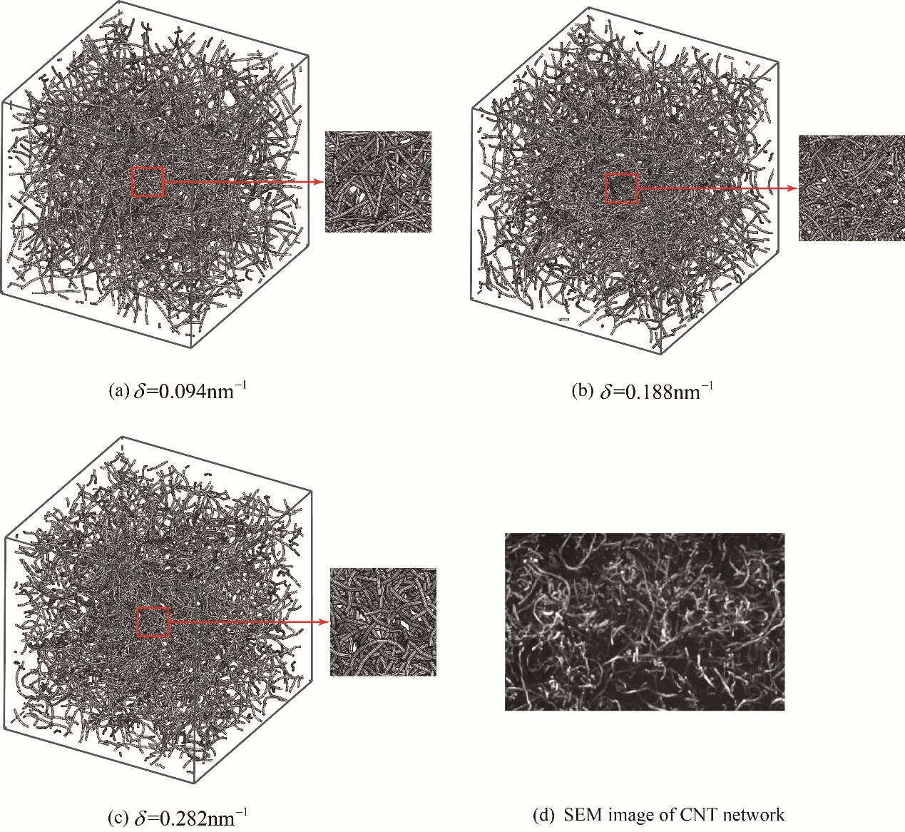

Figure.11: The curved CNT nets with different curvatures

Fig.12 and Fig.13 show the variation of Young’s modulus of the nanocomposites versus the CNT curvature and volume fraction. The effective Young’s modulus at each combination is the average of the 3 samples. Fig.12 indicates that the effective Young’s modulus decrease with increasing CNT curvature and this phenomenon is also observed in many other studies [2,3,22,37]. The numerical results are also compared with the experimental results of CNT–epoxy composites [38] and the result at matches well with the experimental data. The good agreement between the reported experimental data and the numerical results also validates the capability of the proposed method in solving complex problems.

In addition, Fig.13 demonstrates that the decrement of effective Young’s modulus is almost linear from to and the slopes for are , and , respectively. It demonstrates that the reduction of Young’s modulus becomes more tangible when the CNT volume fraction increases and this conclusion is similar with the study by Roham [21].

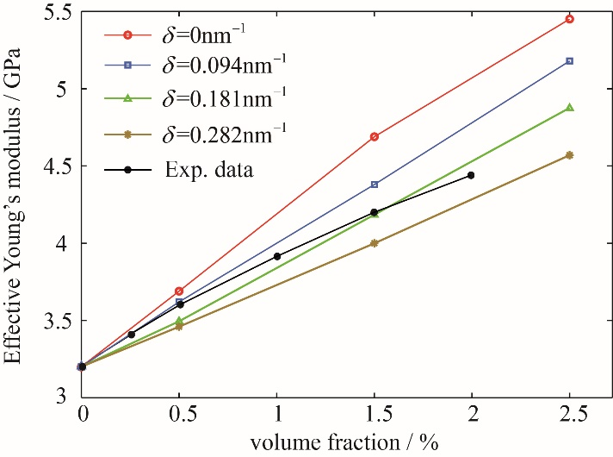

Figure.12: Variation of effective Young’s modulus of the nanocomposites with different curvatures versus volume fraction

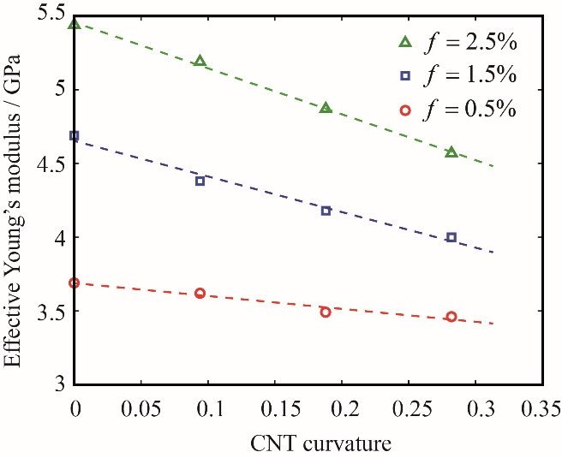

Figure.13 Variation of effective Young’s modulus of the nanocomposites with different volume fractions versus curvature

1. Conclusion

In this study, we propose an Immersed Finite Element method to simulate the mechanical behavior of CNT-reinforced polymer. The CNT and polymer grid are allowed to be created independently, so it is able to easily handle the complex CNT morphology in reality. Both kinematic and mechanic relations between CNT and polymer are considered by embedding the equilibrium equation of each CNT into the equilibrium equation of polymer. Numerical examples indicate that the results of the Immersed FE method are very close to the traditional FE method, so it could provide reliable prediction for complicated problems. This method is used to studies influence of CNT waviness on the Young’s modulus of nano-composites and the numerical results indicate that the CNT waviness plays a negative role in the reinforcement. The numerical results show a good agreement with the experimental data, thus validating the capability of the Immersed FE method in solving complex problems.

Reference

[1] Krishnan A, Dujardin E, Ebbesen EW, Yianilos PN, and Treacy MMJ. Young’s modulus of single-walled nanotubes. *Physical Review B*, 58:14013-14019, 1998.

[2] Fisher FT and Bradshaw RD and Brinson LC. Effects of Nanotube Waviness on the Modulus of Nanotube-Reinforced Polymers. *Applied Physics Letters*, 80:4647-4649, 2002.

[3] Fisher FT amd Bradshaw RD and Brinson LC. Fiber waviness in nanotube-reinforced polymer composites-I: Modulus predictions using effective nanotube properties. *Composites Science and Technology*, 63:1689–1703, 2003.

[4] Alian AR and Meguid SA. Interfacial and mechanical properties of epoxy nanocomposites using different multiscale modeling schemes. *Composite Structure*, 131:545–555, 2015.

[5] Alian AR and Meguid SA. Large-scale atomistic simulations of CNT-reinforced thermoplastic polymers. *Composite Structures*, 191:221–230, 2018.

[6] Alian AR and Meguid SA. Multiscale modeling of the coupled electromechanical behavior of multifunctional nanocomposites. *Composite Structure*, 208:826–835, 2019.

[7] Yakobson BI, Brabec CJ, and Bernholc J. Nanomechanics of carbon tubes: instabilities beyond linear response. *Physical Review Letters*, 76:2511–2514, 1996.

[8] Shi DL, Feng XQ, Jiang H, Huang YY, and Hwang KC. Multiscale Analysis of Fracture of Carbon Nanotubes Embedded in Composites. *International Journal of Fracture*, 134:369–386, 2005.

[9] Wong EW, Sheehan PE, and Lieber CM. Nanobeam mechanics: elasticity, strength, and toughness of nanorods and nanotubes. *Science*, 277:1971–1975, 1997.

[10] Farid F, Abraham, Robert W, Gao HJ, Duchaineau M, Tomas D, and Seager M. Simulating materials failure by using up to one billion atoms and the world’s fastest computer: Work-hardening. *Proceedings of the National Academy of Sciences*, 99:5783–5787, 2002.

[11] Gao GH, Cagin T, and Goddard WA. Energetics, structure, mechanical and vibrational properties of single walled carbon nanotubes. *Nanotechnology*, 9:184–191, 1998.

[12] Chen H, Xue Q, Zheng Q, Xie J, and Yan K. Influence of Nanotube Chirality, Temperature, and Chemical Modification on the Interfacial Bonding Between Carbon Nanotubes and Polyphenylacetylene. *The Journal of Physical Chemistry C*, 112:16514–16520, 2008.

[13] Lusti HR and Gusev AA. Finite element predictions for the thermoelastic properties of nanotube reinforced polymers. *Modelling and Simulation in Materials Science and Engineering*, 12:S107-S119, 2004.

[14] Hone J, Whitney C, Piskoti C, and Zettl A. Thermal conductivity of single-walled carbon nanotubes. *Physical Review B*, 59:2514–2516, 1999.

[15] Dastgerdi JN, Marquis G, and Salimi M. Micromechanical modeling of nanocomposites considering debonding and waviness of reinforcements. *Composite Structures*, 110:1–6, 2014.

[16] Majid K, Abbas M, and Rahmatollah G. On the elasto-plastic behavior of CNT-polymer nanocomposites. *Composite Structures*, 160:782–791, 2017.

[17] Shao LH, Luo RY, Bai SL, and Wang J. Prediction of effective moduli of carbon nanotube-reinforced composites with waviness and debonding. *Composite Structures*, 87:274–281, 2009.

[18] Griebel M and Hamaekers J. Molecular Dynamics Simulations of the Elastic Moduli of Polymer-Carbon Nanotube Composites. *Computer Methods in Applied Mechanics and Engineering*, 193:1773–1788, 2004.

[19] Treacy MMJ, Ebbesen TW, and Gibson JM. Exceptionally high young’s modulus observed for individual carbon nanotubes. *Nature*, 381:678–680, 1996.

[20] Lachman N and Wagner HD. Correlation Between Interfacial Molecular Structure and Mechanics in CNT/Epoxy Nano-Composites. *Composites, Part A*, 41:1093–1098, 2009.

[21] Roham R. Influence of carbon nanotube waviness on the stiffness reduction of CNT/polymer composites. *Composite Structures*, 97:304–309, 2013.

[22] Dimitrios S, George S, Vissarion P, and Manolis P. Effect of waviness and orientation of carbon nanotubes on random apparent material properties and RVE size of CNT reinforced composites. *Composite Structures*, 152:870–882, 2016.

[23] Ganguli S, Bhuyan M, Allie L, and Aglan H. Effect of a Multi-Walled Carbon Nanotube Reinforcement on the Fracture Behaviour of a Tetrafunctional Epoxy. *Journal of Materials Science*, 40:3593–3595, 2005.

[24] Chowdhury SC and Okabe T. Computer simulation of carbon nanotube pull-out from polymer by the molecular dynamics method. *Composites*, 38:747–754, 2007.

[25] Chowdhury SC and Okabe T. Computer simulation of carbon nanotube pull-out from polymer by the molecular dynamics method. Composites, Part A, 38:747–754, 2007.

[26] Tans SJ, Devoret MH, Dai H, Thess A, Smalley RE, Geerligs LJ, and Dekker C. Individual Single-Wall Carbon Nanotubes as Quantum Wires. *Nature*, 386:474–477, 1997.

[27] Frankland SJV, Caglar A, Brenner DW, and Griebel M. Molecular Simulation of the Influence of Chemical Cross-Links on the Shear Strength of Carbon Nanotube-Polymer Interfaces. *The Journal of Physical Chemistry B*, 106:3046–3048, 2002.

[28] Frankland SJV, Harik VM, Odegard GM, Brenner DW, and Gates TS. The Stress-Strain Behavior of Polymer-Nanotube Composites from Molecular Dynamics Simulation. *Composites Science and Technology*, 63:1655-1661, 2003.

[29] Mori T and Tanaka K. Average Stress in Matrix and Average Elastic Energy of Materials with Misfitting Inclusions. *Acta Metallurgica*, 21:571–574, 1973.

[30] Xiao T and Liao K. A Nonlinear Pullout Model for Unidirectional Carbon Nanotube-Reinforced Composites. *Composites*, Part B, 35:211–217, 2004.

[31] Thostenson TT and Chou TW. On the elastic properties of carbon nanotube based composites: modelling and characterization. *Journal of Physics D: Applied Physics*, 47:573–582, 2014.

[32] Chou TW. Microstructural Design of Fiber Composites. *Cambridge University Press*, 1992.

[33] Odom TW, Huang JL, Kim P, and Lieber CM. Atomic Structure and Electronic Properties of Single-Walled Carbon Nanotubes. *Nature*, 391:62–64, 1998.

[34] Liu TX, Phang IY, Shen L, Chow SY, and Zhang WD. Morphology and Mechanical Properties of Multiwalled Carbon Nanotubes Reinforced Nylon-6 Composites. *Macromolecules*, 37:7214–7222, 2004.

[35] Lordi V and Yao N. Molecular Mechanics of Binding in Carbon-Nanotube-Polymer Composites. *Journal of Materials Research*, 15:2770–2779, 2000.

[36] Chen XL and Liu YJ. Square Representative Volume Elements for Evaluating the Effective Material Properties of Carbon Nanotube-Based Composites. *Computational Materials Science*, 29:1–11, 2004.

[37] Alian AR, Borgi SE and Meguid SA. Multiscale modeling of the effect of waviness and agglomeration of CNTs on the elastic properties of nanocomposites. *Computational Materials Science*, 117: 195-204, 2016.

[38] Omidi M, Rokni DHT, Milani AS, Seethaler RJ and Arasteh R. Prediction of the mechanical characteristics of multi-walled carbon nanotube/epoxy composites using a new form of the rule of mixtures. *Carbon*, 48: 3218-3228, 2010.